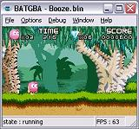
No, it's not Batman, it's BatGBA, a promising new Gameboy Advance emulator.

